 Greenwood Township 
Monthly Meeting Minutes
APRIL 10th, 2024
- This Meeting was Called to Order by Al Mohler @ 7:00 p.m.
- The Pledge of allegiance was presented.
- Roll Call: Al Mohler (Supervisor) Ronda Jonas (Clerk) Joann Cerka (Treasurer) Shelly Bigelow (Trustee) Wesley Westbrook (Trustee) Jason Nelson (Fire chief)
- Public Present: Terry & Kim Vandercook, Mike Mix, Harold Swinehart, Terry Garbrecht, Thelma Paul, Dick & Jodi LaBarr, Arron Sogge
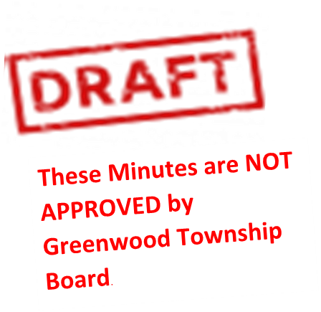
- Ronda made motion to accept the minutes as presented, Joann second all in favor motion carried.
- Public comments:
- Terry Garbrecht requested the board to make a motion do a 10 year pay freeze for the township board.
- Thelma Paul asked about the minutes for the February meetings to be on website? We did two meetings in January so we did not have any February minutes.
Old Business
- Al met with Davis cost of the foundation repair; floor support will be around $8,000. Ronda made a motion to get the foundation and foundation the floor support done second by Shelly all in favor, motion carried. Al is to get with Davis and he will get a Start Project date.
New Business
- Ronda called Krazy Kats sign for the bulletin board, the sign for the front of the building, and the Greenwood scenic overlook sign, He will send a quote after spring break. Tabled for next meeting
- Ronda made a motion to finish up the newsletter and get them out to residents and post on board. Second by Joanne all in favor, motion carried.

- Ronda made motion to accept the treasure report as presented, second by Joann all in favor, motion covered.
These Minutes are NOT APPROVED by Greenwood Township Board.
Fireboard
- Shelly Bigelow spoke to everyone about the 2 tablets and 2 hook ups at the meeting.
Treasurer Report & Bills
- Ronda Made a motion to accept the treasure report as presented, second by Joann all in favor, motion carried.
- Ronda made motion to pay the bills, second by Joann all in favor, motion carried.
- Wes made motion to adjourn second by Al all in favor, motion carried.

By: Clerk, Ronda Jonas

